Assignment #5

One-way functions and complexity theory, part 2

The Basics
Before class on Wednesday 10/1: read this document and make note of any questions you might have.

Wednesday 10/1 and Friday 10/3, and Monday 10/6: will be studio classes devoted to this assignment.

Wednesday 10/8 is the career fair and there will be no class.

Friday 10/10: present your assignments

Friday 10/17: final version due in class.

Getting back to L (yes the assignments break across this theorem), the “<” means compare the two strings as numbers. If they are numerically the same then compare their lengths.
There is a nondeterministic turing machine that accepts L and runs in polynomial time. Can you see how it works? Call this machine N. Recall that most NPTMs (nondeterministic polynomial-time turing machines) work in two phases: a non deterministic-phase where they guess a “solution” (this is usually called a “witness,” or a “proof” by theoreticians), followed by a deterministic one, where they check whether their guess was true.

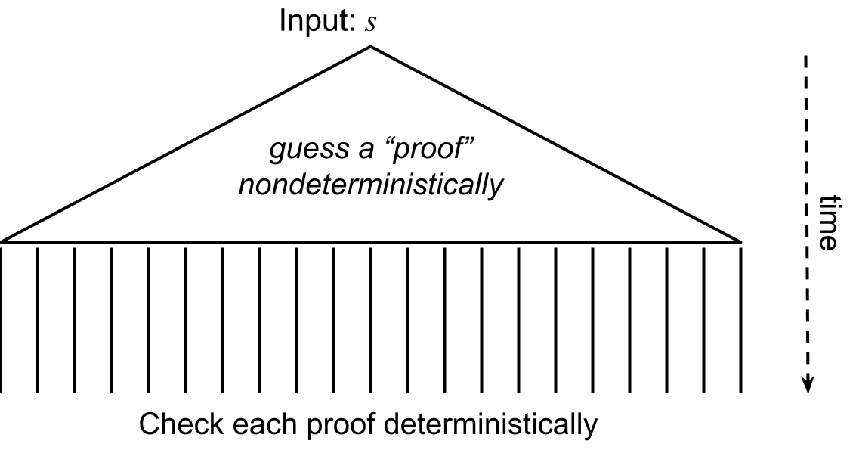

Describe how such a machine could accept L. You may use the figure above (or redraw) to help explain.

What would this machine guess as a proof?

How would it check whether the proof is correct?

How do we know that this runs in polynomial time?

Now, back to the proof. We now have an NPTM that accepts L. This means that L is in NP. Now suppose that P = NP. That would mean that L is also in P. So let M be a deterministic Turing machine that accepts L. Show (with pseudocode) that we can use that machine to invert f in polynomial time.

f ⁻¹: on input y,

But this implies that f is not one-way, which is a contradiction. Therefore L is not in P and P ≠ NP.

It turns out that we can go the other way too.

Theorem 3: If P ≠ NP then one-way functions exist.

Proof. Assume that P ≠ NP. Let L be a language that is NP but not P. Let N be an NPTM that accepts L (note, these are not the same L and N as in Theorem 2. We are just reusing the names here). Your job is to construct a function f that uses a verifier for N as a subroutine. The trick is that there is a way to construct it so that if f is not one-way, then L can be computed in deterministic polynomial time (using the inverse of f).

Describe f here.

Describe a deterministic, polynomial-time Turing machine that accepts L, using a deterministic, polynomial-time algorithm for f ⁻¹, under the assumption that such an algorithm exists.

Note that this contradicts our assumption that L is not in P. Therefore we must assume that f is one-way.

